C++ Programming 24-06-2024

Day 1 , Task 1: C progams:

1.C program to reverse a given string without using any additional library functions.

#include<stdio.h>

#include<string.h>

int main()

{

char a[50] = "hello world";

printf("string : %s\n",a);

int len = strlen(a);

for(int i=0 , j=len-1 ; i <=j ; i++ , j--)

{

char c = a[i];

a[i] = a[j];

a[j] = c;

}

printf("reversed string: %s",a);

return 0;

}

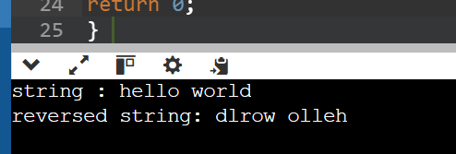

2.Explain the concept of pointers in C and write a program to swap the values of two variables using pointers.

Pointer : A pointer can store the address of a variable.

#include<stdio.h>

void swap(int *p,int *q)

{

int temp=*p;

*p=*q;

*q=temp;

}

int main()

{

int a=5;

int b=10;

printf("before swapping: a=%d , b=%d \n",a,b);

swap(&a,&b);

printf("after swapping: a=%d , b=%d \n",a,b);

return 0;

}

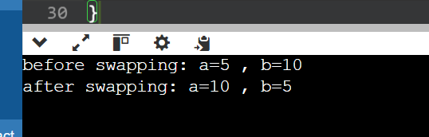

2.Implement a function in C that takes an integer array and its size as arguments and sorts the elements of the array in ascending order using a selection sort algorithm.

#include <stdio.h>

#include <stdbool.h>

void selectionSort(int arr[], int n)

{

for(int i =0 ; i < n - 1 ; i++)

{

int min_index = i;

for(int j = i + 1 ; j < n ; j++ )

{

if (arr[j] < arr[min_index])

{

min_index=j;

}

}

int temp = arr[i];

arr[i] =arr[min_index];

arr[min_index] = temp;

}

}

int main()

{

int arr[5] = {12, 5, 10, 15, 2};

int n = sizeof(arr) / sizeof(arr[0]);

selectionSort(arr,n);

printf("Sorted array: \n");

for (int i=0;i<n;i++)

{

printf(" %d ",arr[i]);

}

printf("\n");

return 0;

}

